# **How to run JMeter tests from the command line**

#### ***Why execute tests in non-GUI mode?***

The JMeterGUI’s inability to handle huge loads and excessive resource consumption risks overloading the server, which would give you inaccurate test results information. Additionally, the less load you can generate throughout your tests, the more resource-intensive the server is.

***Sample Request***

|  |  |
| --- | --- |
| 1  2  3  4 | {      "name": "Test",      "job": "JMeter"  } |

***Sample Response***

|  |  |
| --- | --- |
| 1  2  3  4  5  6 | {    "name":"Test",    "job":"JMeter",    "id":"955",    "createdAt":"2023-07-03T15:46:18.038Z"  } |

### ***Create a Test Plan in JMeter by following the below-mentioned steps***

#### ***Step 1 –  Add Thread Group***

* Select Test Plan on the tree
* Add Thread Group                                                                                                                               ***To add Thread Group:***Right-click on the “Test Plan” and add a new thread group: ***Add -> Threads (Users) -> Thread Group***

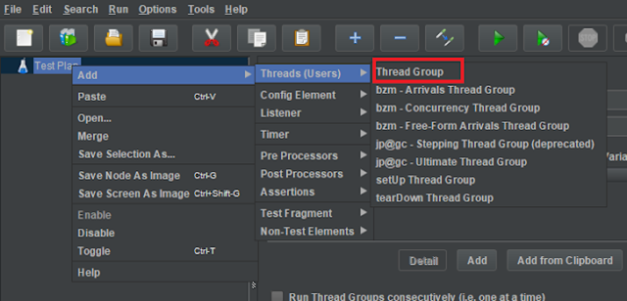

In the Thread Group control panel, enter Thread Properties as follows: We will take an example of row no 5

***Number of Threads*:** 5 – Number of users connects to the target website  
***Loop Count*:** 5  – Number of times to execute testing  
***Ramp-Up Period*:** 5 – It tells JMeter how long to delay before starting the next user. For example, if we have 5 users and a 5 -second Ramp-Up period, then the delay between starting users would be 1 second (5 seconds /5 users).

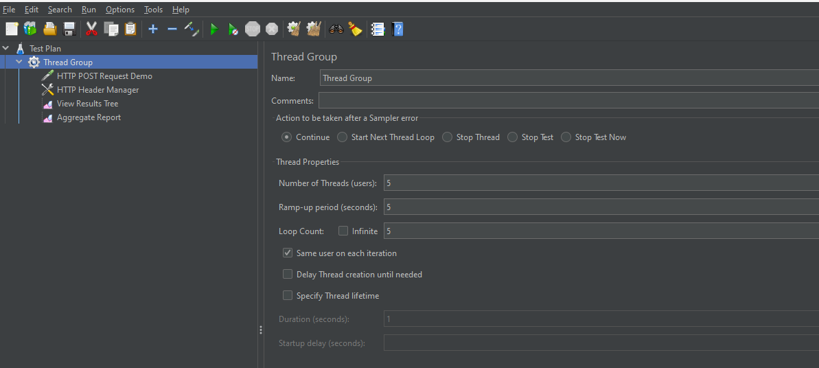

#### ***Step 2 –  Adding JMeter elements***

The JMeter element used here is HTTP Request Sampler. In HTTP Request Control Panel, the Path field indicates which URL request you want to send

***2.1 Add HTTP Request Sampler***To add: Right-click on Thread Group and select: ***Add -> Sampler -> HTTP Request***

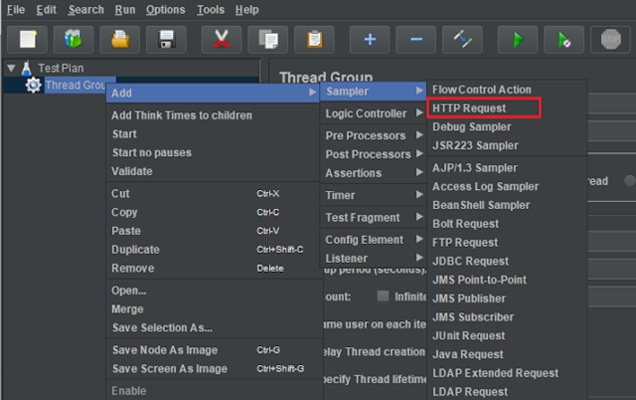

The below-mentioned are the values used in HTTP Request to perform the test

* ***Name***– HTTP POST Request Demo
* ***Server Name or IP*** – reqres.in
* ***Port*** – Blank
* ***Method***– POST
* ***Path*** – /api/users

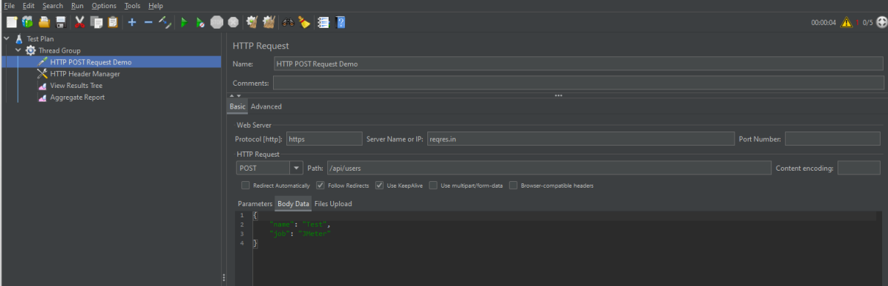

***2.2 Add HTTP Head Manager***

The Header Manager lets you add or override HTTP request headers like can add Accept-Encoding, Accept, Cache-Control

To add: Right-click on Thread Group and select: ***Add -> Config Element -> HTTP Read Manager***

The below-mentioned are the values used in Http Request to perform the test  
***Content-type*** = application/json  
***accept***– application/json

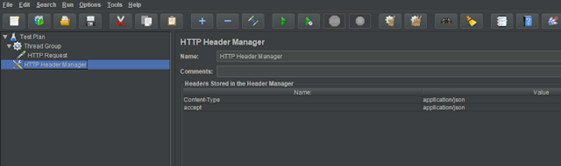

#### ***Step 3 – Adding Listeners to Test Plan***

***Listeners***– They show the results of the test execution. They can show results in a different format such as a tree, table, graph, or log file  
We are adding the ***View Result Tree listener***

***View Result Tree*** – View Result Tree shows the results of the user request in basic HTML format  
To add: Right-click on Test Plan***, Add -> Listener -> View Result Tree***

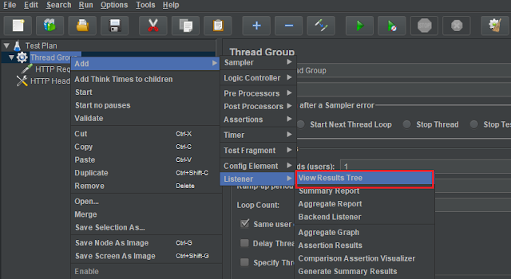

***Aggregate Report***

It is almost the same as Summary Report except Aggregate Report gives a few more parameters like, “Median”, “90% Line”, “95% Line” and “99% Line”.

 To add: Right Click on ***Thread Group > Add > Listener > Aggregate Report***

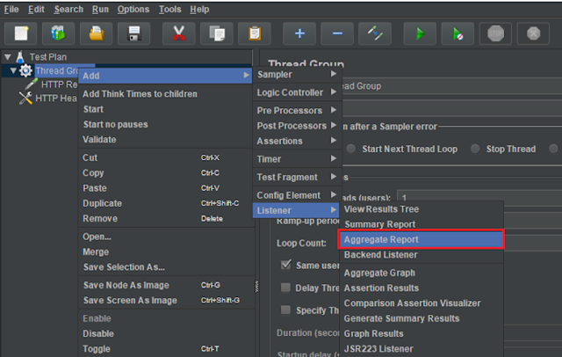

#### ***Step 4 – Save the Test Plan***

To Save: Click File ***Select -> Save Test Plan as ->Give the name of the Test Plan***. It will be saved in .jmx format.

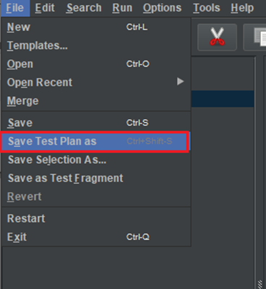

The below image shows that the test is saved in ***Documents***with the name ***POST_Load.jmx.***

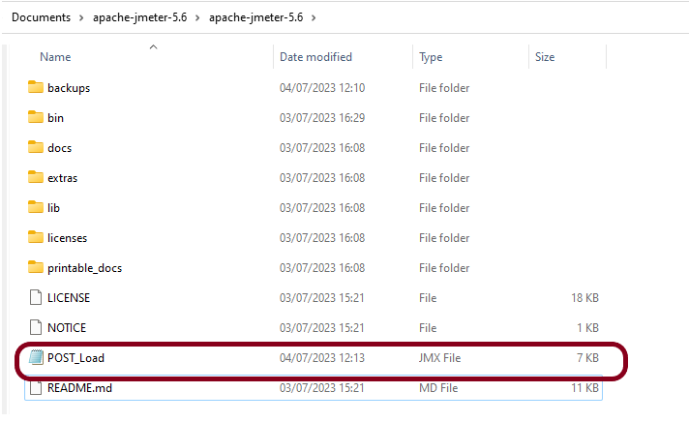

#### ***Step 5  – Run the Test Plan* from Command Line**

Open the command prompt and go into JMeter’s bin folder.

|  |  |
| --- | --- |
| 1 | cd C:\Users\Vibha\Documents\apache-jmeter-5.6\apache-jmeter-5.6\bin |

#### ***Step 6 – View the Execution Status***

Enter the following command:

|  |  |
| --- | --- |
| 1 | jmeter -n –t test.jmx -l testresults.jtl |

This is the command used in the script:

|  |  |
| --- | --- |
| 1 | jmeter -n -t C:\Users\Vibha\Documents\apache-jmeter-5.6\apache-jmeter-5.6\POST_Load.jmx -l C:\Users\Vibha\Documents\JMeterResult\result.jtl |

Below is the detail about the commands used in the execution.

**-n:**This specifies JMeter is to run in cli mode

**-t:** [name of JMX file that contains the Test Plan]

**-l:**[name of JTL file to log sample results to]

The test execution is displayed in the command line as shown below:

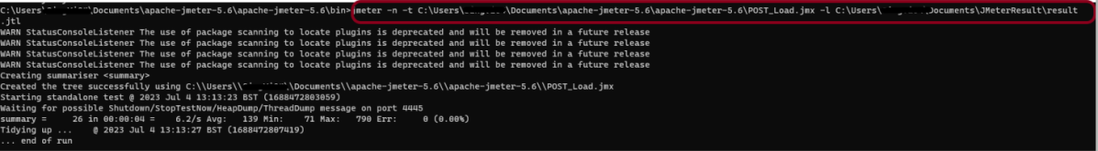

The ***result.jtl***is saved as mentioned in the above command in the ***JMeterResult*** folder present in ***Documents***:

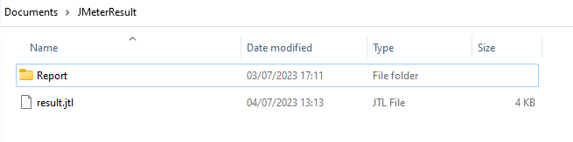

Let us open the ***result.jtl***file.

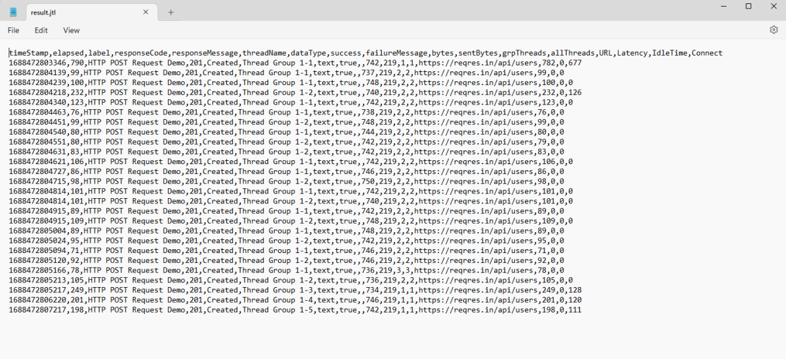

It is very difficult to understand the result in this format. So, open JMeter in GUI mode.  
Mention the location of the file in the Filename of the ***“View Results Tree”*** listener and hit enter. We can see the result now.

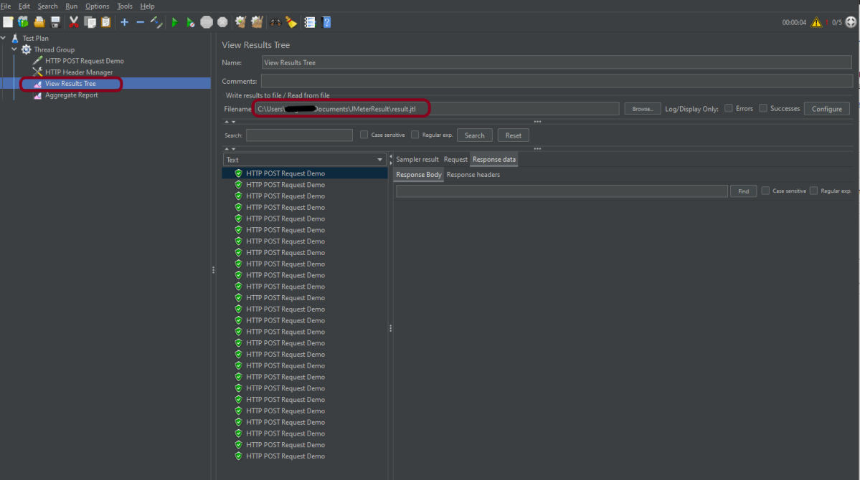

Click on***Response data*** and Response Header to view other information about Response.

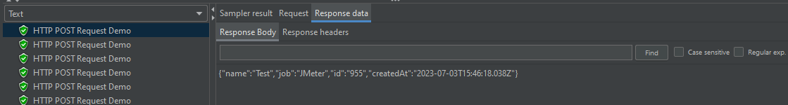

We are done! Congratulations on making it through this tutorial and hope you found it useful! Happy Learning!!